The setting of Jotham’s parable
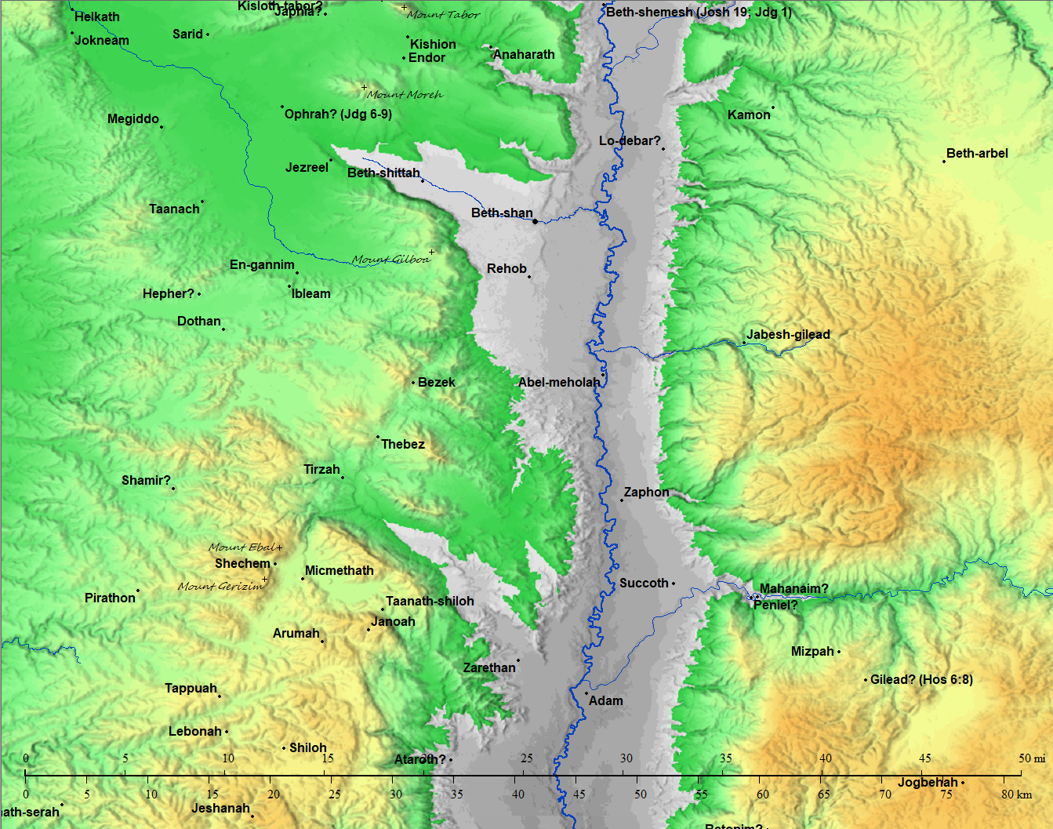
The precise location of the city of Ophrah in Judges 6-9 is uncertain. For more information on the two cities of Ophrah mentioned in the Bible see www.jewishvirtuallibrary.org/ophrah
- The city of Shechem was in the valley between Mount Ebal & Mount Gerizim (~0.7-1 mile span from one mount to the other).
  - If you’ve never spoken or listened from such a position, on a quiet day it is possible to hear someone speaking at normal volume from one side of a valley to the other.
- Jotham lifted up his voice, and cried (Judges 9:7c,7d). That is, he spoke very loudly which would make it very easy for anyone in the valley below to hear him clearly.

Judges 8:33
33 And it came to pass, as soon as Gideon was dead, that the children of Israel turned again, and went a whoring after Baalim, and made Baal-berith their god.

Judges 9:4
4 And they gave him threescore and ten pieces of silver out of the house of Baal-berith, wherewith Abimelech hired vain and light persons, which followed him.
- The children of Israel forsook God and at Shechem was a house for their idol Baal-berith.
- They had rejected God and were clearly amenable to having a human king (Judges 9:1-4).
The Hebrew culture is steeped with wisdom which is taught in parables and there are many such easy to find examples in both Biblical and extra-Biblical sources. Here are just a few that appear in the Bible:
- The parable of the ewe lamb (2 Samuel 12:1-4).
- Jehoash’s parable (2 Kings 14:9,10).
- The parable of the vineyard (Isaiah 5:1-7).
- The parable of the sluggard (Proverbs 20:4).
- The parables of Jesus in Matthew, Mark, & Luke.

Definitions of some words used in this document.

Noah Webster's American Dictionary of the English Language, abridged, 1828

PAR'ABLE, n. [L. parabola; Gr. to throw forward or against, to compare to or against; as in confero, collatum, to set together, or one thing with another.]

A fable or allegorical relation or representation of something real in life or nature, from which a moral is drawn for instruction; such as the parable of the trees choosing a king, Judg 9; the parable of the poor man and his lamb. 2 Sam 12; the parable of the ten virgins, Mat 25.

PAR'ABLE, v.t. To represent by fiction or fable.

HE'BREW, n. [Heb. Eber, either a proper name, or a name denoting passage, pilgrimage, or coming from beyond the Euphrates.]

One of the descendants of Eber, or Heber; but particularly, a descendant of Jacob, who was a descendant of Eber; an Israelite; a Jew.

HE'BREW, a. Pertaining to the Hebrews; as the Hebrew language or rites.

HE`ARKEN, v.i. h`arken.

1. To listen; to lend the ear; to attend to what is uttered, with eagerness or curiosity.
The furies hearken, and their snakes uncurl.

2. To attend; to regard; to give heed to what is uttered; to observe or obey.
Hearken, O Israel, to the statutes and the judgments which I teach you. Deu 4.

3. To listen;; to attend; to grant or comply with.
Hearken thou to the supplication of thy servant.
l Kings 8.

HE`ARKEN, v.t. h`arken. To hear by listening. [Little used.]

Webster's Unabridged Dictionary, 1913 - Amenable

A·me’na·ble
1. (Old Law) Easy to be led; governable, as a woman by her husband. [Obs.] Jacob.
4. Willing to yield or submit; responsive; tractable.

The purpose of Jotham’s parable
Judges 9:7f-7h
Hearken unto me, ye men of Shechem, that God may hearken unto you.
- Jotham’s trust in God is evident right from his opening statement.
- Jotham doesn’t use his familial status or his father Gideon’s fame to challenge Abimelech.

Jotham’s parable
Judges 9:8-15
8 The trees went forth on a time to anoint a king over them; and they said unto the olive tree, Reign thou over us.
9 But the olive tree said unto them, Should I leave my fatness, wherewith by me they honour God and man, and go to be promoted over the trees?
10 And the trees said to the fig tree, Come thou, and reign over us.
11 But the fig tree said unto them, Should I forsake my sweetness, and my good fruit, and go to be promoted over the trees?
12 Then said the trees unto the vine, Come thou, and reign over us.
13 And the vine said unto them, Should I leave my wine, which cheereth God and man, and go to be promoted over the trees?
14 Then said all the trees unto the bramble, Come thou, and reign over us.
15 And the bramble said unto the trees, If in truth ye anoint me king over you, then come and put your trust in my shadow: and if not, let fire come out of the bramble, and devour the cedars of Lebanon.

Jotham explains his parable and presents his case
Judges 9:16-20
16 Now therefore, if ye have done truly and sincerely, in that ye have made Abimelech king, and if ye have dealt well with Jerubbaal and his house, and have done unto him according to the deserving of his hands;
17 (For my father fought for you, and adventured his life far, and delivered you out of the hand of Midian:
18 And ye are risen up against my father's house this day, and have slain his sons, threescore and ten persons, upon one stone, and have made Abimelech, the son of his maidservant, king over the men of Shechem, because he is your brother;)
19 If ye then have dealt truly and sincerely with Jerubbaal and with his house this day, then rejoice ye in Abimelech, and let him also rejoice in you:
20 But if not, let fire come out from Abimelech, and devour the men of Shechem, and the house of Millo; and let fire come out from the men of Shechem, and from the house of Millo, and devour Abimelech.
- Take note of what Jotham does not do and that he presents his case as if before a judge (v19,20).
- Note also that the bramble’s statements are both proud and haughty (Proverbs 16:18) whereas the olive tree, the fig tree, and the vine are content to both stay and serve.

Parable key
Object | Description | Represents
The olive tree, the fig tree, the vine | Productive plants that provide fruit | Gideon
The trees, cedars of Lebanon | Decorative trees that provide no fruit | The men of Shechem, the house of Millo (forsook God, idolatry)
Bramble | A rough, prickly shrub or a thorn-tree (buckthorn). | Abimelech

